**CS3354 Software Engineering**

**Final Project Deliverable 1**

100%

Susana Lainez, Amy Abraham , Nguyen Le, Orlando Garcia,

Soumaya Hajji, Daniel Arrant, James Ostlind

**Feedback Provided:** (from Proposal)

* + Dear All,

Thank you so much for the original ideas you proposed. Essentially, each team can go ahead and start working on their proposed project. In the meantime, please make sure that you include the following in your **final project deliverable 2 (final deliverable)**:

- A comprehensive research to find similar project implementations. Cite your findings properly using IEEE citation format.

- Make sure that you are adding extra feature(s) to uniquely differentiate your design from already existing similar implementations. Clearly explain what these feature(s) are.

- A comparison of your design with similar implementations in the field. This could be in any format of your choice, such as a table, paragraphs, charts, etc.

Best of luck with your projects and hope everyone enjoys working on them.

* + To comply with the feedback, we researched other dating apps and explained how our app is different from those out in the market.

---Proposal---

* - **The title of your project:** 100%
* - the group members (firstname and lastname)
  + Susana Lainez
  + Amy Abraham
  + Nguyen Le
  + Orlando Garcia
  + Soumaya Hajji
  + Daniel Arrant
  + James Ostlind
* - **What you will be doing:**
  + Creating a dating application that pairs users using common interests. Based on how many common interests a person has with another individual, a person is assigned a compatibility ratio from 0% to 100%. Questions involving common books, movies, tv shows, music, hobbies, etc. will be asked when the user starts a profile. As users start swiping through potential matches, they will see how compatible (percentage-wise) they are with other individuals on the application. Along with that filters such as distance, religion, occupation,etc. will also be available for users.
* - **A detailed description of your motivation (why you chose to do this particular  
  project), where you expect your design to be used in real life.**
  + Individuals are often looking for new people to meet and interact with. However, with how busy they are with classes and work, it can become hard to get out there and introduce yourself to new individuals, especially for those that tend to be more introverted. As a result, we have decided to create a dating app that allows individuals to interact with other people that possess similar interests in categories such as movies, TV shows, books, and music.

Based on these criteria, the 100% algorithm will provide the user with a number between 1 and 100 based on how compatible two individuals are. This is different than current dating apps on the market for it provides the user with a rating on how compatible they are with others, something that is not included in applications like Tinder and Bumble. However, similar to other dating apps, 100% displays the pictures of other users, as well as some of their information like name and age, as well as the incorporation of direct message so that users can interact with one another. In addition, current dating apps like tinder also have similar features were you can swipe one way or the other depending on whether you like a person or not, allowing for more user interaction and feedback [2].

* -  **The list of tasks delegated to each member**
* **Team leader**: Ensure that each assignment is submitted on time, help team coordinator(s) arrange meetings and remind team of special due dates (when they are not available).
  + Member(s): Amy Abraham
* **Team Coordinator**: Arrange meetings and remind team of special due dates.
  + Member(s): Susana Lainez, Nguyen Le
* **Lead Designer**: Ensure that the diagrams are drawn out nicely and clearly with sufficient details.
  + Member(s): Daniel Arrant
* **Lead Programmer**: Make sure that the code is well implemented.
  + Member(s): James Ostlind
* **Team Member**: Help with project and update any changes that were made with the team on either Scrum or any other framework.
  + Member(s): Soumaya Hajji, Orlando Garcia

---End of Proposal---

**Setting Up a GitHub Repository:**

<https://github.com/souhajji/3354-100percent>

**Delegation of Tasks:**

Soumaya Hajji: Created the GitHub Repository, added collaborators and created project_proposal and uploaded files, created a Use Case diagram.

Nguyen Le: Helped with the project_scope and created the sequence diagrams.

Amy Abraham: Created the README commit, wrote about the software process model and architectural model we plan to use, created class diagram.

Susana Lainez: Created project_scope and committed the changes to the repository. Created Class diagram, implemented feedback in project proposal.

Orlando Garcia: Created functional and non-functional requirements under software requirements section.

Daniel Arrant: Worked on MVC architecture diagram and partly on non-functional requirements

James Ostlind: Helped with the sequence diagrams.

**Software Process Model:**

Spiral Model is the model we will be using in the development of our dating application. The Spiral model combines the iterative nature of prototyping and the systematic aspect of the waterfall model. This means that we will be able to continuously make changes as the software evolves. Changes according to customer preferences and new application updates will be able to be performed if the Spiral model is used as the Software process model for this project.

**Software Requirements:**

* **Functional Requirements**
  + Matches users based on mutual interests.
  + It allows users to swipe through people with similar interests.
  + Gives a 1-100 compatibility percentage between two users.
  + Will allow interaction between matched users through messaging.
  + Users will swipe up if they’re interest or down if they’re not interested.
* **Non-Functional Requirements**
  + **Product Requirements**
    - **Efficiency Requirements**
      * **Performance Requirements**
        + App must load matches within 10 seconds.
        + App must evaluate compatibility percentage in 3 seconds or less.
      * **Space Requirements** 
        + App shall not exceed 200MB of space on a user’s phone.
    - **Dependability Requirements**
      * App will always allow communication between two users.
      * Any downtime occurrences should be addressed and fixed within 45 minutes.
      * App will keep user information secure by providing password-protected accounts.
    - **Usability Requirements**
      * App will provide users with accounts to showcase interests, pictures, and a description of themselves.
  + **Organizational Requirements**
    - **Environmental Requirements**
      * App will run Apple’s iOS and Google’s Android mobile operating systems.
      * App will be available for download through Apple’s App Store and Google’s Play Store applications.
    - **Operational Requirements**
      * Users will choose a username and password to access their accounts.
      * User will be able to add data to their profile in the form of pictures, biographies, and interests.
      * App will be able to access files on the users device.
      * Users will be able to report malicious users on the platform.
      * Users will be able to view matched user accounts.
      * Users will be able to send messages to matched users through a messaging interface on the application.
    - **Development Requirements**
      * Android app will be built and maintained using Android Studio IDE, iOS app will be built and maintained using Xcode IDE.
      * Android app will be implemented using Java.
      * iOS app will be implemented using Swift.
  + **External Requirements** 
    - **Regulatory Requirements**
      * No users below the age of 18.
      * Follows Apple’s app store guidelines.
      * Follows Google’s developer policies.
    - **Ethical Requirements**
      * Must discourage the exchange of inappropriate messages between users on the app.
    - **Legislative Requirements**
      * **Accounting Requirements**
        + App must be free to download through Apple’s App Store and Google’s Play Store.
      * **Safety/Security Requirements**
        + App will filter out fake accounts to prevent cybercrime ( online scams, phishing, etc).

**Use Case Diagram:**

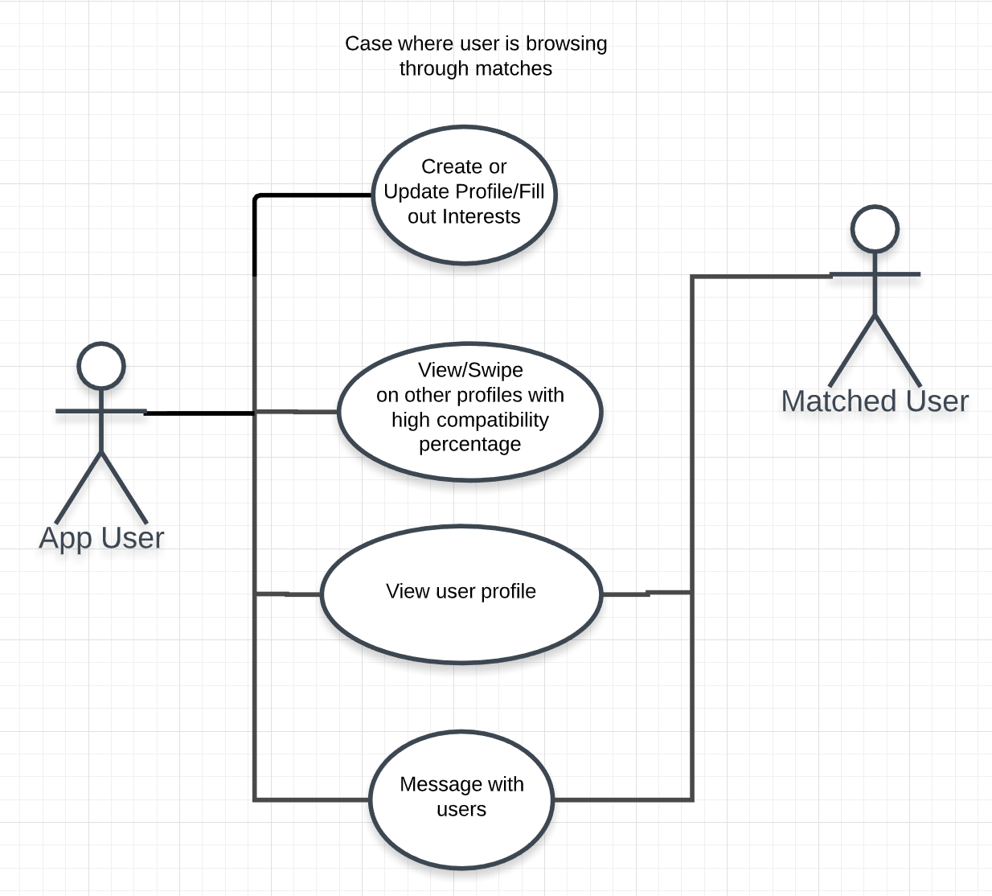

**Sequence Diagram:**

**Create profile/Fill out interests**

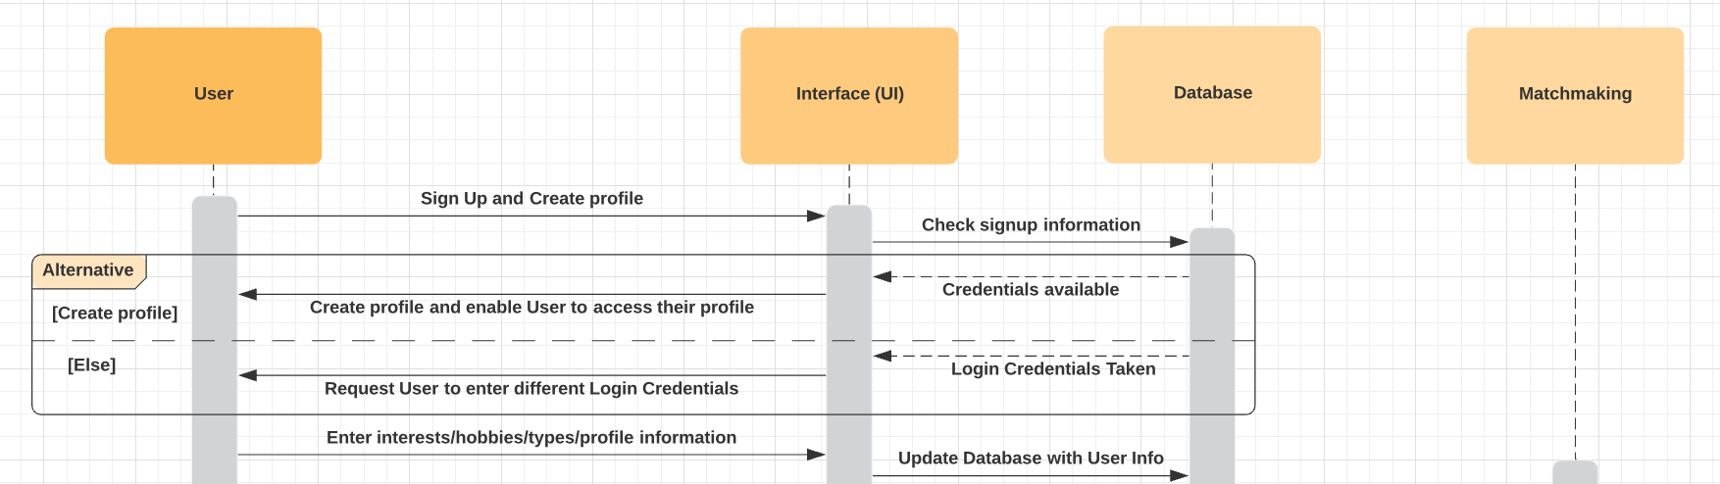

**Matchmaking**

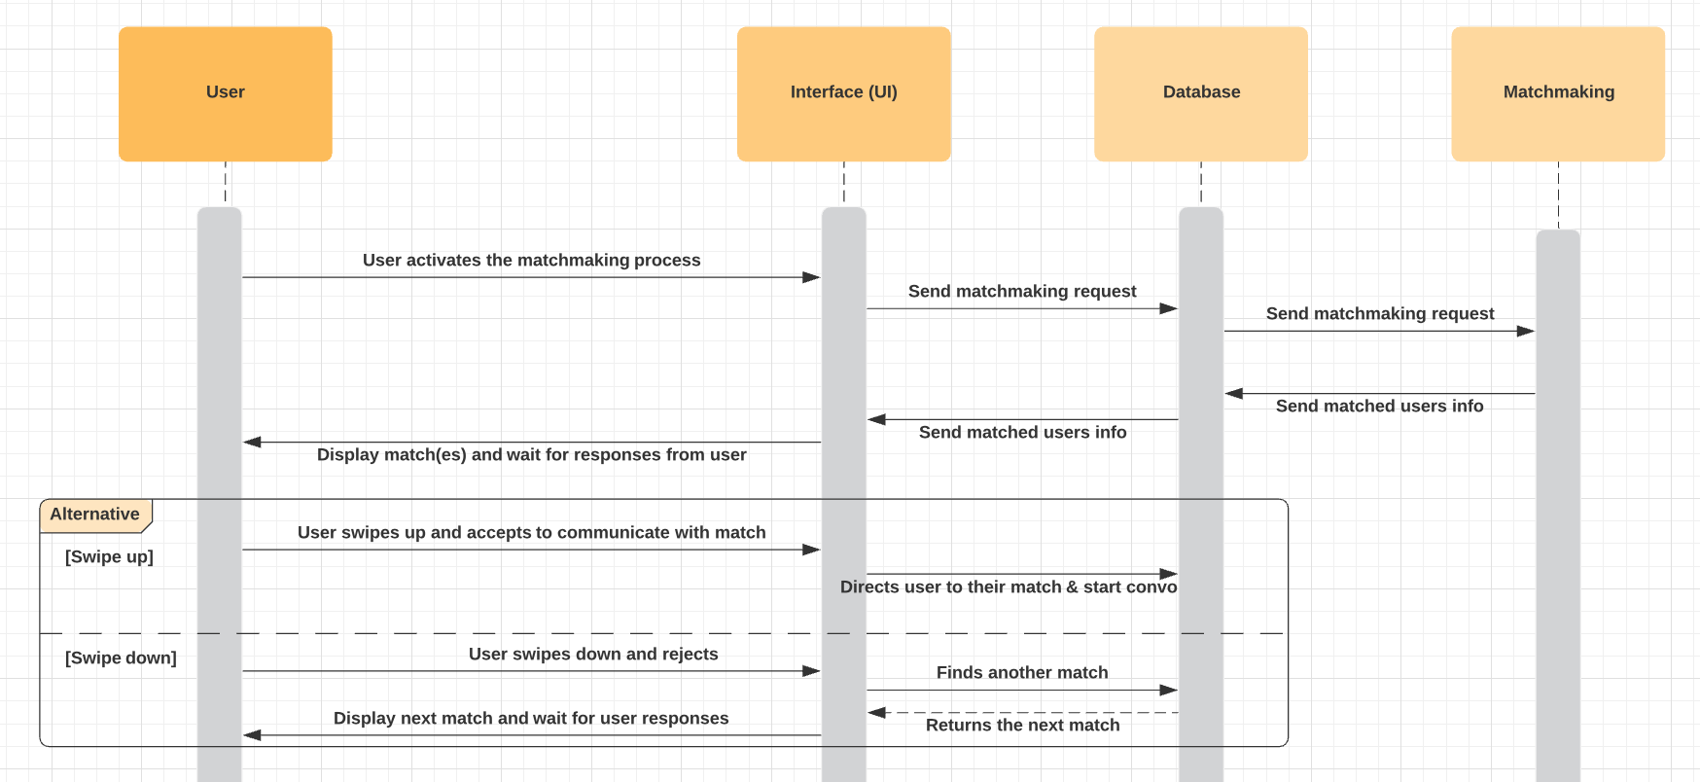

**View user profile:**

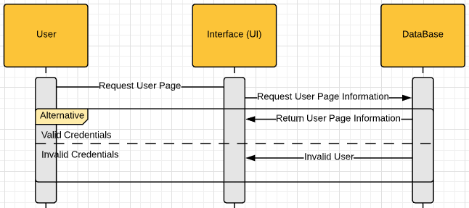

**Message with users:**

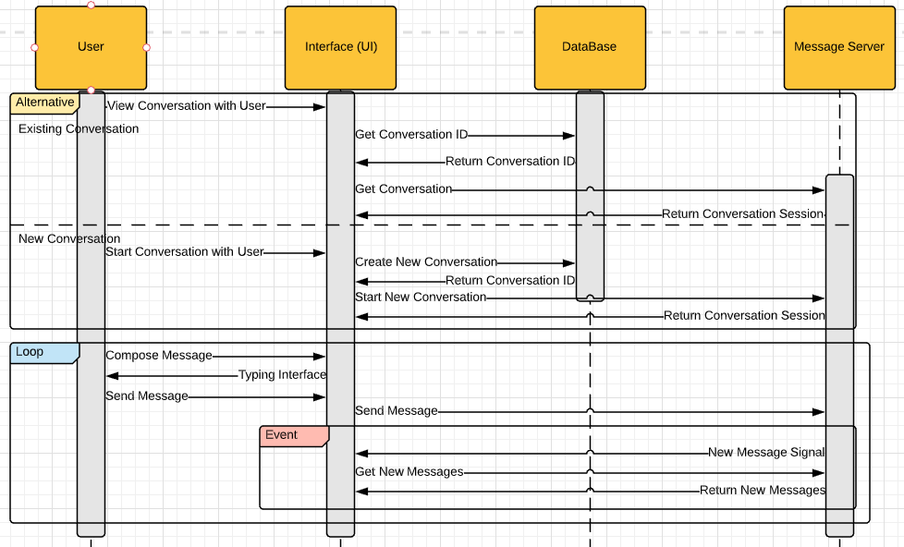

**Class Diagram:**

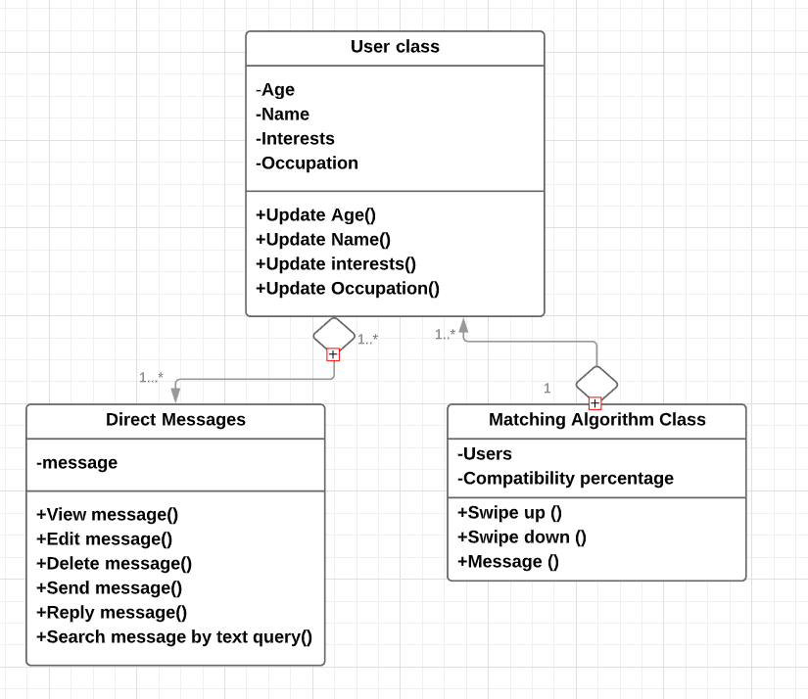

**Architectural Design: MVC Pattern**

The architectural pattern we will use is MVC because changes to system data, presentation of the data, and how the user interacts with the data all correlate and work together for a software application. For our dating app, user interaction is extremely important and MVC takes into account user interaction and adjusts data and the presentation of the data on the app. It is a simple pattern that is seen used in many softwares that allows for changes and easily shows the interactions between components in software.

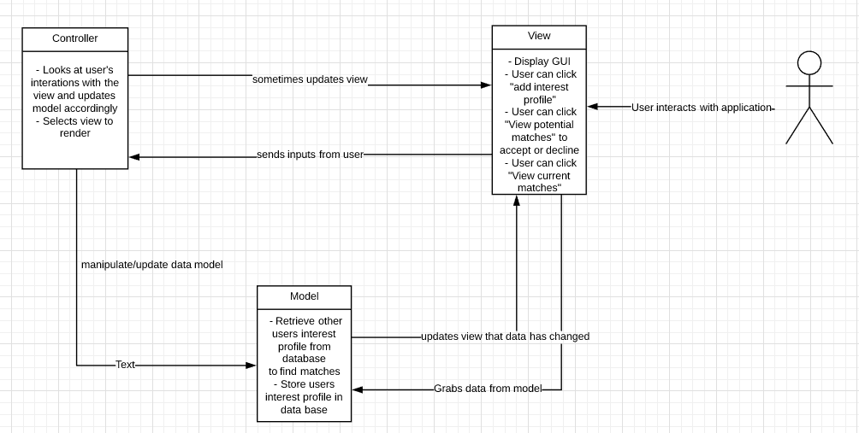

Work Cited

Apple Inc, “App Store Review Guidelines,” *App Store Review Guidelines - Apple Developer*, 12-Sep-19AD. [Online]. Available: https://developer.apple.com/app-store/review/guidelines/. [Accessed: 18-Oct-2019].

[2] M. Jansen, “Looking for Love or Just Some Fun? Cozy up with the Best Dating Apps of

2019.” *Digital Trends*, 17 Oct. 2019. [Online] Available: [ww.digitaltrends.com/mobile/best-dating-apps/](http://www.digitaltrends.com/mobile/best-dating-apps/). [Accessed on: 17 Oct. 2019]

“Date, Meet, Network Better,” *Bumble*. [Online]. Available: https://bumble.com/en/. [Accessed: 17-Oct-2019].

“Developer Policy Center,” *Google*. [Online]. Available: <https://play.google.com/about/developer-content-policy/>. [Accessed: 18-Oct-19]

“Find the people you've crossed paths with,” *happn*. [Online]. Available: https://www.happn.com/en/. [Accessed: 17-Oct-2019].

“Match. Chat. Date.,” *Tinder*. [Online]. Available: https://tinder.com/?lang=en. [Accessed: 17-Oct-2019].

OkCupid, “Free Online Dating,” *OkCupid*. [Online]. Available: https://www.okcupid.com/. [Accessed: 17-Oct-2019].